9-1: Using GROUP BY and HAVING Clauses

Vocabulary

Used to specify which groups are to be displayed; restricts groups that do not meet group criteria HAVING

Divides the rows in a table into groups GROUP BY

Try It / Solve It

1. In the SQL query shown below, which of the following is true about this query?

___T___ a. Kimberly Grant would not appear in the results set.

___F___ b. The GROUP BY clause has an error because the manager_id is not listed in the

SELECT clause.

___F___ c. Only salaries greater than 16001 will be in the result set.

___F___ d. Names beginning with Ki will appear after names beginning with Ko.

___F___ e. Last names such as King and Kochhar will be returned even if they don’t have

salaries > 16000.

SELECT last_name, MAX(salary)

FROM employees

WHERE last_name LIKE 'K%'

GROUP BY manager_id, last_name

HAVING MAX(salary) >16000

ORDER BY last_name DESC ;

2. Each of the following SQL queries has an error. Find the error and correct it. Use Oracle

Application Express to verify that your corrections produce the desired results.

a. SELECT manager_id

FROM employees

GROUP BY manager_id

HAVING AVG(salary) < 16000;

b. SELECT COUNT(title)

FROM d_cds

WHERE cd_number < 93;

c. SELECT type_code

FROM d_songs

WHERE duration IN('3 min', '6 min', '10 min') AND id < 50

GROUP BY type_code;

d. SELECT loc_type, rental_fee AS Fee

FROM d_venues

WHERE id <100

GROUP BY "Fee"

ORDER BY 2;

3. Rewrite the following query to accomplish the same result:

SELECT DISTINCT MAX(song_id)

FROM d_track_listings

WHERE track IN ( 1, 2, 3);

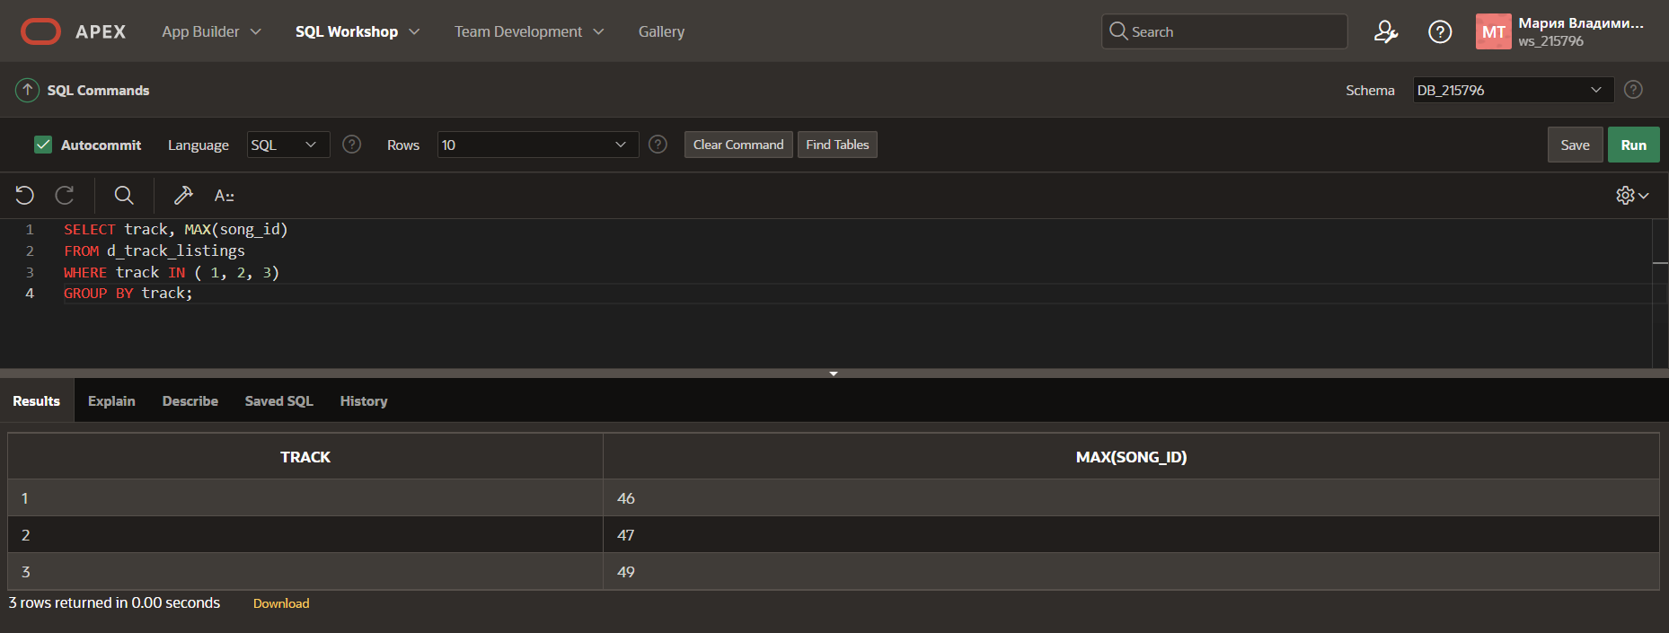

4. Indicate True or False

__T__ a. If you include a group function and any other individual columns in a SELECT clause,

then each individual column must also appear in the GROUP BY clause.

__F__ b. You can use a column alias in the GROUP BY clause.

__F__ c. The GROUP BY clause always includes a group function.

5. Write a query that will return both the maximum and minimum average salary grouped by department from the employees table.

6. Write a query that will return the average of the maximum salaries in each department for the employees table.

